COMPLETED THIS GROUP CONTRACT 🡪 ☐
Group members (GROUP 1):
First name | Last name | DISC personalities (2)

Process to complete Learning Task No. 1:
- Complete the tasks below (GROUP CONTRACT) in this shareable document (your professor can see how you are progressing as a group) before date and time.
- Send a message to your professor that your group is done completing this group contract.
- Receive an email from your professor with the randomly assigned report to critique (within 1-2 days).
- Work on completing Learning Task No. 1 with your group.
- Attend the follow up 15 min. meeting with your group on date at the time below, to talk about your progress and address any questions your group may have.
☐ | Time | Group 1

- Submit Learning Task No. 1 by date and time. One submission per group.

Sunday | Monday | Tuesday | Wednesday | Thursday | Friday | Saturday
17 | 18  Work on this contract and start completing the readings | 19 | 20 | 21 | 22 | 23
24 | 25  Submit this contract before our Zoom Class and start LT1 after you receive the report | 26 | 27 | 28 | 29  Attend follow up meeting with your professor. | 30
31 | Feb-1  Zoom class | 2 | 3 | 4 | 5  Submit LT1 by 11:59 pm through the Dropbox on D2L
Note: You can continue accessing this document to add additional tasks before date to ensure you are on track.
GROUP CONTRACT

STEP 1:
Watch the following video together or before you meet the first time, to understand how you could become an ideal team player from Patrick Lencioni and discuss it with your group.

STEP 2:
Complete the following steps:
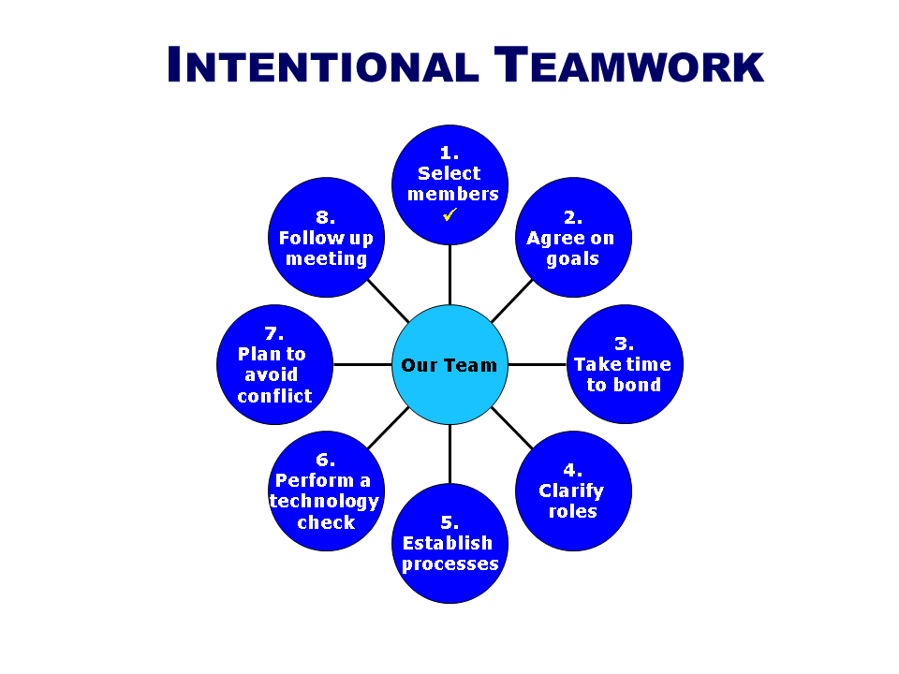
1st - Identify your strengths:
Members | Strengths that could add value to the group

2nd - Create your goals:
<Press TAB after point 3, if you have another goal>

3rd - Share 3 strategies to bond as a team, that you will implement before your submit this contract

4th – Clarify your roles
Member | Roles

5th – Establish processes
By <date, time> | Task | Responsible(s)
<Press TAB after the last row if you would like to add another task or row>

6th – Perform a technology check:
☐ | Ensure that all the members can access this shareable document
☐ | Ensure that everyone knows how to access all the readings
☐ | Create a shareable document to submit LT1 (see the course outline)

7th - Share 3 steps to solve conflict:

8th – Create a plan to share your progress and ask questions on January 29th
Agenda item | Responsible(s)

