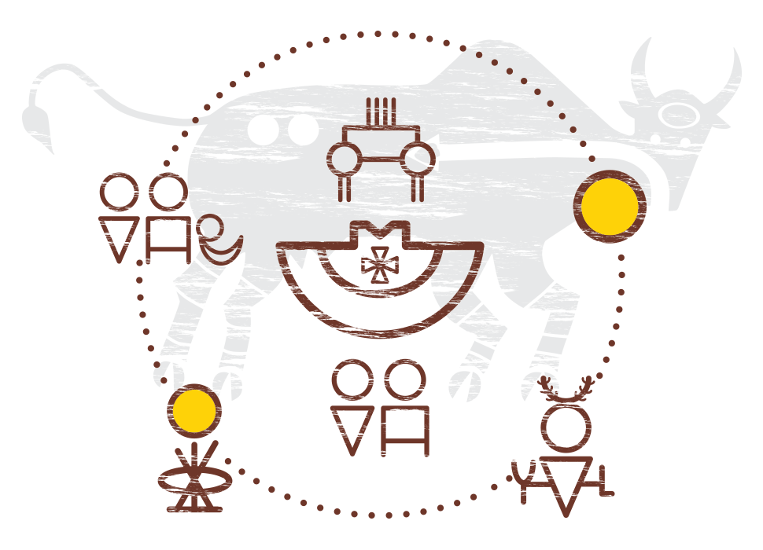

**Belly Button Teachings**

*A Cree activity shared by Jennifer Ward from the Center for Teaching and Learning, University of Alberta*

The Cultural Model of ii’tah’poh’to’p (Indigenous Strategy, University of Calgary)

OVERVIEW & PURPOSE

Who are we, really?

*tante ohci kiya*, a Nehiyawk (Cree) term, translates to “Who are you connected to?” and asks us to engage in a belly button teaching to introduce ourselves in an Indigenous way.

Belly button teachings allows us to speak from a personal space of connectedness to ancestry, family, friends, and land—and the importance of those relationships in shaping who we are.

LEARNING OUTCOME FOR THIS ACTIVITY

* At the end of this activity, students will be able to recognize the value of an Indigenous teaching and learning practice that begins to deepen our personal understanding of ourselves, each other, and the land, in a good way.

MATERIALS NEEDED

1. A presentation slide which recognizes the activity as an Indigenous way of knowing, the purpose of the activity, instructions, and a question for reflection
2. Online interactive presentation software(e.g.,<https://www.mentimeter.com/>)

ACTIVITY - 5 minutes

A belly button teaching asks us to tell the story of who we really are by thinking about who we are connected to. When thinking about introducing ourselves in this way, Jennifer Ward offered a caveat and explained that this activity was not meant to cause distress but rather help us think about the many ways we could interpret what family meant to us, where we’re from, where we live, and how we connect to the land. This is an important reminder to help establish a tone of respect, safety, and inclusion. Consider the following steps:

Step 1. Welcome your students to the course

Step 2. Open your course with a territorial acknowledgement (e.g., here is [the University of Calgary’s](https://www.ucalgary.ca/indigenous-strategy/resources/territorial-acknowledgements))

Step 3. Model the belly button teaching and introduce yourself by sharing who you are connected to using family images, a map, a story, or a combination of all of these.

Step 4. Explain the origin and purpose of the activity.

Step 5. Ask students to find a partner and share who they are connected to.

Step 6. After 5 minutes, bring the class back together and check in with their learning.

VERIFICATION

First, Jennifer Ward checked for understanding by asking a reflective question.

Q: “Reflect on how you felt about introducing yourself in an Indigenous way. How did it make you feel?”

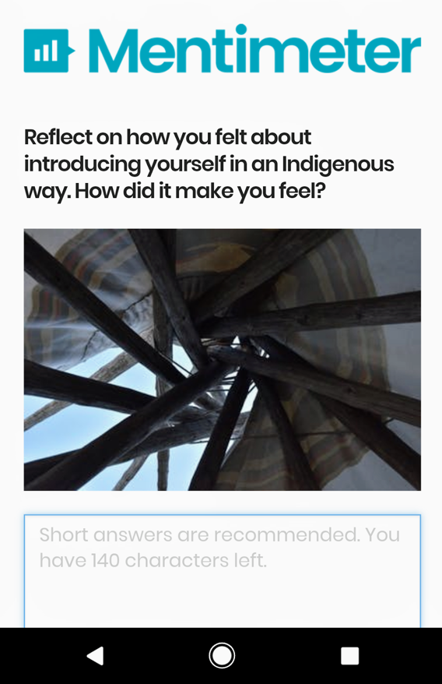

Next, she used technology ([Mentimeter](https://www.mentimeter.com/), see image right) to capture those reflections in a public and safe way. Participation was anonymous and displayed a growing list of responses to the activity in real-time.

An alternate way of extending the reflective question can include:

* **5 minute journaling or drawing:** Students write down or draw how they felt in response to the activity and keep it to themselves or choose to share.